Red Team - Outland Adventures Database Project

Team Members
Matthew Rozendaal
Mickelly Audam
Tiffany Davidson

Case Study Selected
Outland Adventures

Project Introduction
This document contains the business rules, assumptions, and the initial entity relationship diagram for the Outland Adventures case study. The purpose of this project is to design a working database solution that supports trip bookings, equipment rentals and purchases, customer accounts, staff tracking, and business reporting needs.

Business Rules
- Each customer must have one customer account.
- A customer account may include one or more family members.
- Each family member must have a signed waiver before participating in a trip.
- If a family member is under 18, a parent must sign the waiver.
- Each booking is tied to one trip and one customer account.
- Trips occur in Africa, Asia, or Southern Europe.
- Customers may rent or purchase equipment.
- Each equipment transaction must be recorded as either a rental or purchase.
- Equipment must have a purchase date to track age.
- Inventory items older than five years must be identifiable through reporting.
- Each customer account may have multiple two factor authentication methods.
- Only one two factor method may be marked as primary.
- Staff members are assigned roles such as Guide, Marketing, Inventory, Developer, and Admin.
- Each trip may have multiple bookings.
- Downward trends in bookings must be measurable by region.
- Equipment sales must be measurable separately from rentals.

Assumptions
- Customer demand for guided trips will continue to grow.
- Customers may book trips for multiple family members.
- All customers will access the system through the ecommerce site.
- Trip region values will remain limited to Africa, Asia, and Southern Europe.
- Equipment category and condition are stored as text for simplicity.
- Staff members are assumed to work all trips without a separate trip assignment table.

Initial Entity Relationship Diagram
The initial ERD includes the following main entities: CustomerAccount, FamilyMember, Trip, Booking, Equipment, EquipmentTransaction, Waiver, TwoFactorMethod, and Staff. The ERD diagram is maintained using dbdiagram.io and reflects the full structure of relationships and attributes used in this project.
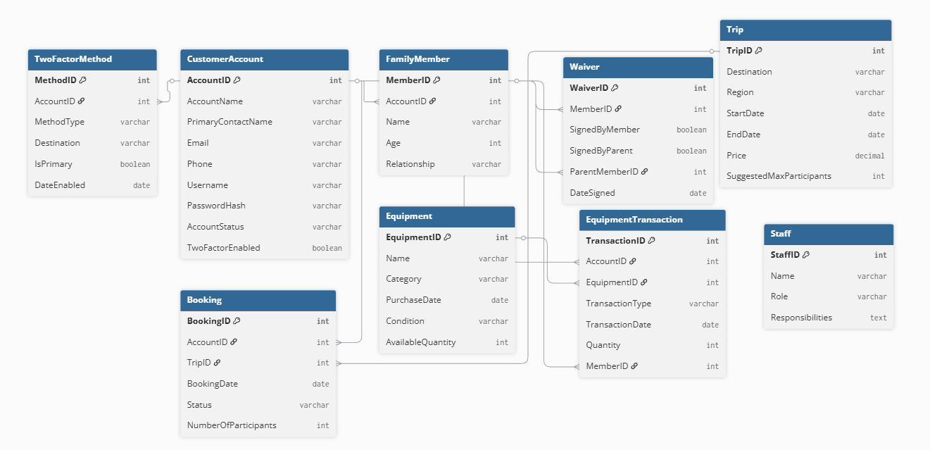

Functional and Reporting Requirements
- Permissions (User Roles):
  - Admin
    - JFord
    - BTimmerson
  - Guide
    - JMacnell
    - DMarland
  - Marketing
    - AGallegos
  - Inventory
    - DStravopolous
  - Customer
    - Default User (Customer)
  - Developer
    - MWong
Functional Requirements
- Sales Analysis Module
  - Track rental vs. purchase ratios
  - Generate reports on profitability of equipment sales
- Booking Analytics
  - Monitor bookings by region (Africa, Asia, Southern Europe)
  - Identify downward trends in customer interest
- Inventory Management System
  - Flag items older than 5 years
  - Track usage, condition, and replacement needs
- E-commerce Platform
  - Display trip schedules and availability
  - Enable online equipment rental/purchase
  - Provide secure payment method
Non-Functional Requirements
- Scalability: System must handle growth in customers and trips
- Reliability: Accurate reporting and inventory tracking
- Security: Protect customer data and payment information
Entities & Attributes
CustomerAccount
- AccountID (PK)
- AccountName (e.g., "The Smith Family")
- PrimaryContactName
- Email
- Phone
- Username (unique)
- PasswordHash (securely stored, not plain text)
- AccountStatus (Active, Suspended, Closed)
- TwoFactorEnabled (Boolean, default = FALSE)
FamilyMember
- MemberID (PK)
- AccountID (FK → CustomerAccount.AccountID)
- Name
- Age
- Relationship (Parent, Child, etc.)
Trip
- TripID (PK)
- Destination
- Region (Africa, Asia, Southern Europe)
- StartDate
- EndDate
- Price
- SuggestedMaxParticipants
Booking
- BookingID (PK)
- AccountID (FK → CustomerAccount.AccountID)
- TripID (FK → Trip.TripID)
- BookingDate
- Status (Confirmed, Cancelled, Pending)
- NumberOfParticipants
Equipment
- EquipmentID (PK)
- Name
- Category (Tent, Backpack, etc.)
- PurchaseDate
- Condition
- AvailableQuantity
EquipmentTransaction
- TransactionID (PK)
- AccountID (FK → CustomerAccount.AccountID)
- EquipmentID (FK → Equipment.EquipmentID)
- TransactionType (Rental, Purchase)
- TransactionDate
- Quantity
- MemberID (FK → FamilyMember.MemberID, optional)
Waiver
- WaiverID (PK)
- MemberID (FK → FamilyMember.MemberID)
- SignedByMember (Boolean)
- SignedByParent (Boolean)
- ParentMemberID (FK → FamilyMember.MemberID, optional — if under 18)
- DateSigned
TwoFactorMethod
- MethodID (PK)
- AccountID (FK → CustomerAccount.AccountID)
- MethodType (SMS, Email, AuthenticatorApp)
- Destination (Phone number, email, or app identifier)
- IsPrimary (Boolean)
- DateEnabled
Staff
- StaffID (PK)
- Name
- Role (Guide, Marketing, Inventory, Developer, Admin)
- Responsibilities

Relationships
- CustomerAccount ↔ FamilyMember
  - One account can have many family members.
  - Each family member belongs to one account.
- CustomerAccount ↔ Booking
  - One account can make many bookings.
  - Each booking belongs to one account.
- Trip ↔ Booking
  - One trip can have many bookings.
  - Each booking is for one trip.
  - SuggestedMaxParticipants helps manage capacity.
- CustomerAccount ↔ EquipmentTransaction
  - One account can rent or buy multiple equipment items.
  - Each transaction belongs to one account.
  - Optionally linked to a specific family member.
- FamilyMember ↔ Waiver
  - Each family member must have a waiver.
  - If under 18, waiver must reference a parent (ParentMemberID).
- CustomerAccount ↔ TwoFactorMethod
  - One account can have multiple 2FA methods (e.g., SMS + Authenticator App).
  - TwoFactorEnabled = TRUE if at least one method is active.
- Equipment ↔ EquipmentTransaction
  - One equipment item can appear in many transactions.
  - Each transaction involves one equipment item.
- Staff ↔ Trip
  - Guides (subset of staff) are assigned to trips.
  - Many-to-many possible.

Screenshots
